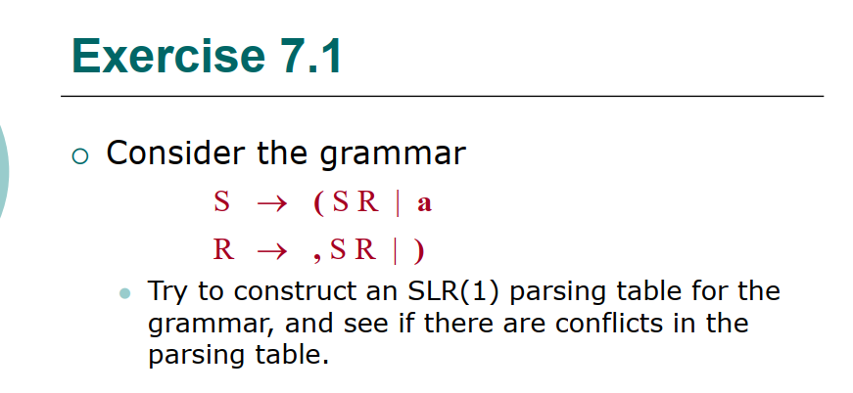

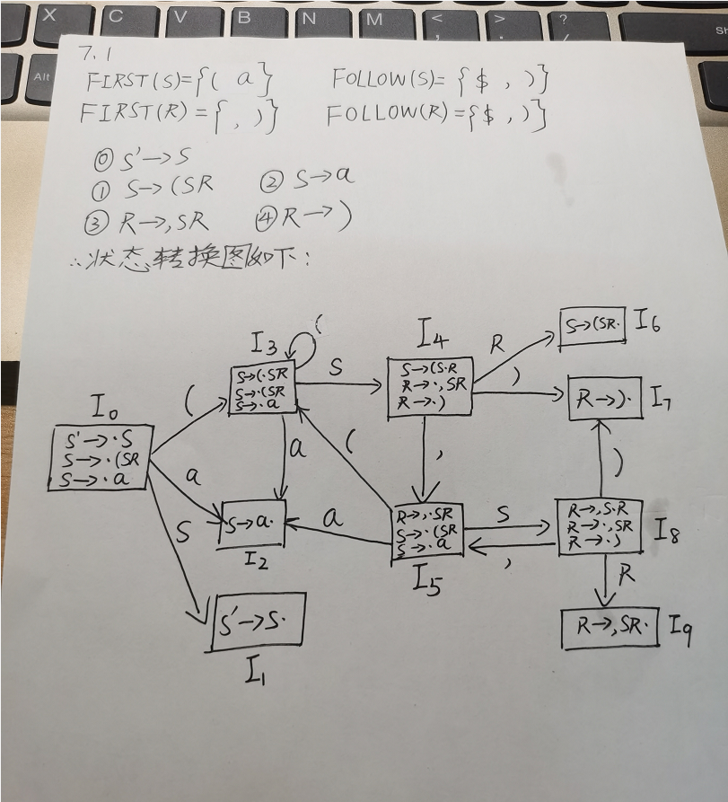

|  |  |  |  |  |  |  |  |
| --- | --- | --- | --- | --- | --- | --- | --- |
| State | ACTION | | | | | GOTO | |
| ( | , | a | ) | $ | S | R |
| 0 | S3 |  | S2 |  |  | 1 |  |
| 1 |  |  |  |  | acc |  |  |
| 2 |  | r2 |  | r2 | r2 |  |  |
| 3 | S3 |  | S2 |  |  | 4 |  |
| 4 |  | S5 |  | S7 |  |  | 6 |
| 5 | S3 |  | S2 |  |  | 8 |  |
| 6 |  | r1 |  | r1 | r1 |  |  |
| 7 |  | r4 |  | r4 | r4 |  |  |
| 8 |  | S5 |  | S7 |  |  |  |
| 9 |  | r3 |  | r3 | r3 |  |  |

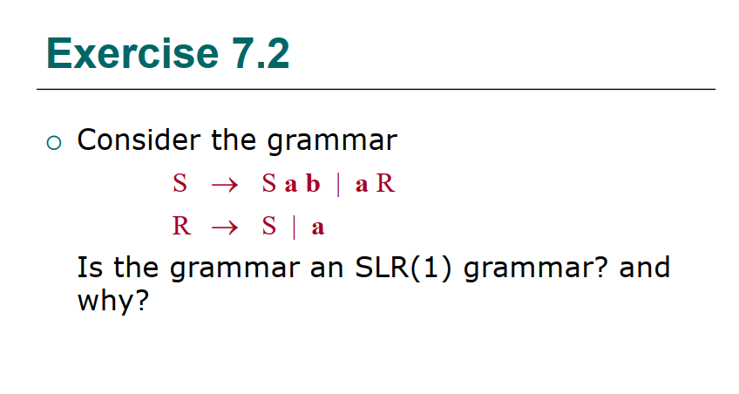

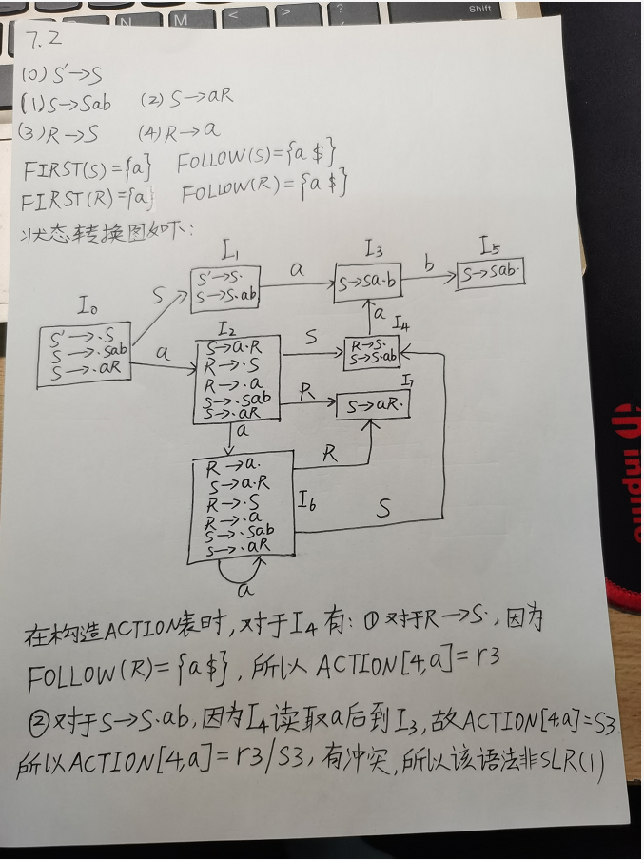

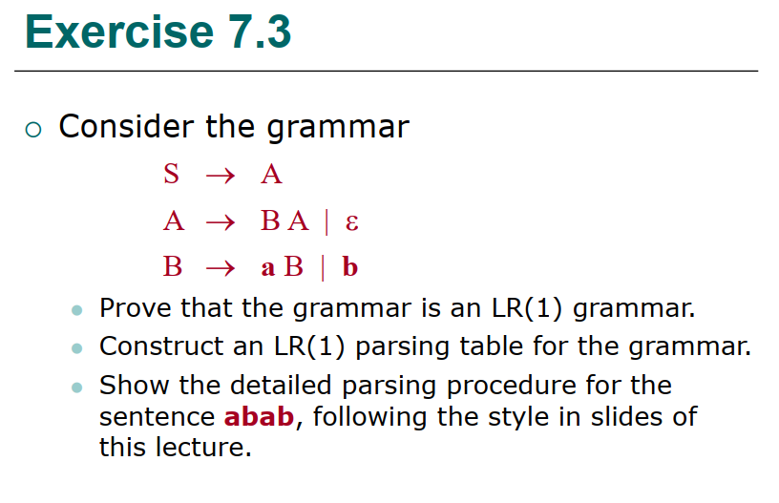

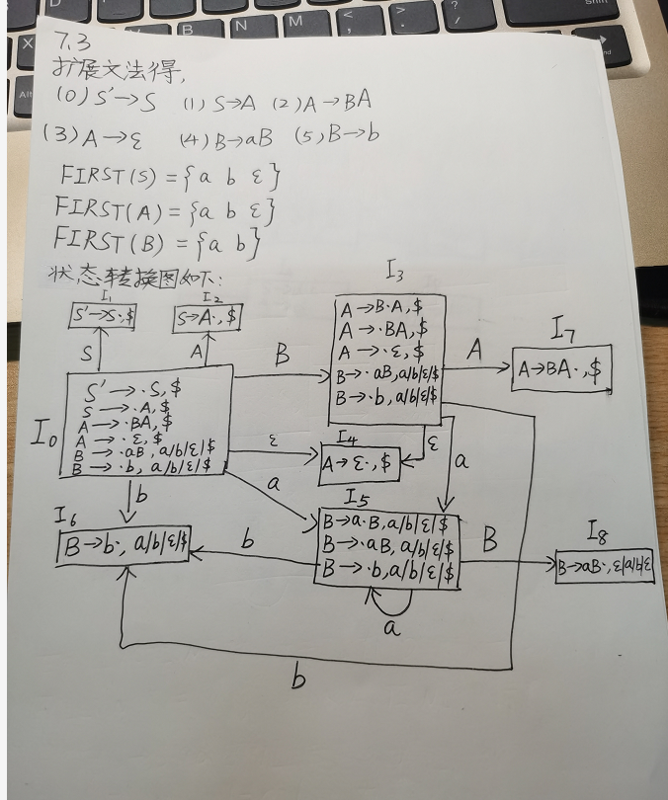

|  |  |  |  |  |  |  |  |
| --- | --- | --- | --- | --- | --- | --- | --- |
| State | ACTION | | | | GOTO | | |
| a | b | $$ε$$ | $ | S | A | B |
| 0 | S5 | S6 | S7 |  | 1 | 2 | 3 |
| 1 |  |  |  | acc |  |  |  |
| 2 |  |  |  | r1 |  |  |  |
| 3 | S5 | S6 | S4 |  |  | 7 | 3 |
| 4 |  |  |  | r3 |  |  |  |
| 5 | S5 | S6 |  |  |  |  | 8 |
| 6 | r5 | r5 | r5 | r5 |  |  |  |
| 7 |  |  |  | r2 |  |  |  |
| 8 | r4 | r4 | r4 | r4 |  |  |  |

由LR(1)分析表可知不存在冲突，所以是LR(1)文法

